**Lab Task 2**

**Numerical Computing Lab(105127)**

**Ali Afzal(63961)**

Q1:

print("Iter----a----b----mid----f(a)----f(b)----f(mid)")

def f(x):

return x**3+3*x-5

def bissection(a,b,tol):

niter=0

while(abs(a-b)>=tol):

mid=(a+b)/2.0

prod1=f(a)*f(mid)

prod2=f(b)*f(mid)

if prod1<0:

b=mid

elif prod2<0:

a=mid

niter+=1

print(niter,"||||",a,"||||",b,"||||",mid,"||||",f(a),"||||",f(b),"||||",f(mid))

return mid,niter

answer,n=bissection(1,2,0.0000000001)

print(answer,n)

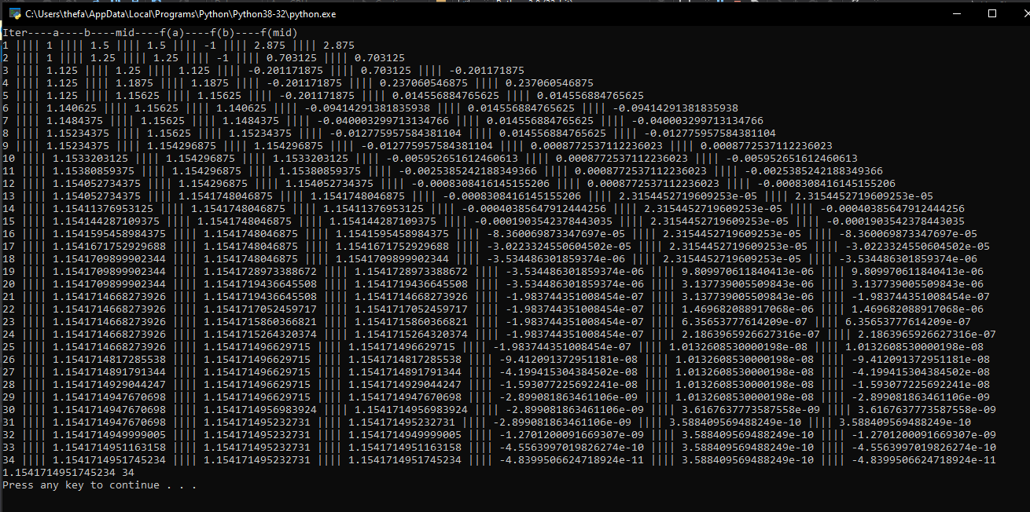

Q2:

|  |  |  |  |  |  |
| --- | --- | --- | --- | --- | --- |
| **S#** | **Functions** | **Starting Interval** | **Tolerance** | **No. Of Iterations** | **Root** |
| 1 | Cos(x)-1.3x = 0 | 0.0001 - 3 | 0.01 | 9 | 0.1348611328125 |
| 0.0001 - 3 | 0.001 | 12 | 0.1341287353515625 |
| 0.0001 - 3 | 0.0001 | 15 | 0.13403718566894532 |
| 2 | xCos(x)-2x2+3x-1=0 | 1 - 3 | 0.01 | 8 | 1.0078125 |
| 1 - 3 | 0.001 | 11 | 1.0146484375 |
| 1 - 3 | 0.0001 | 15 | 1.01458740234375 |
| 3 | 2xCos(2x)-(x+1)2=0 | -3 - 4 | 0.01 | 10 | -1.2705078125 |
| -3 - 4 | 0.001 | 13 | -1.2730712890625 |
| -3 - 4 | 0.0001 | 17 | -1.2734451293945312 |

1)

import math

def f(y):

pi=22/7

j = y*(180/pi)

return math.cos(j)-1.3*y

def bissection(a,b,tol):

niter=0

while(abs(a-b)>=tol):

mid=(a+b)/2.0

prod1=f(a)*f(mid)

prod2=f(b)*f(mid)

if prod1<0:

b=mid

elif prod2<0:

a=mid

niter+=1

return mid,niter

answer,n=bissection(0.0001,3,0.0001)

print(answer,n)

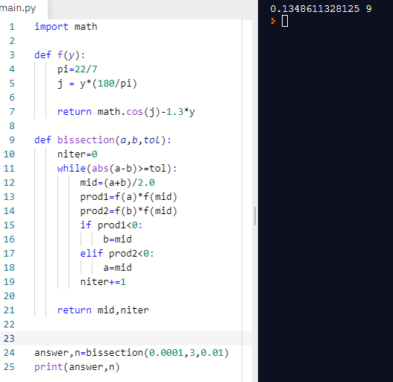

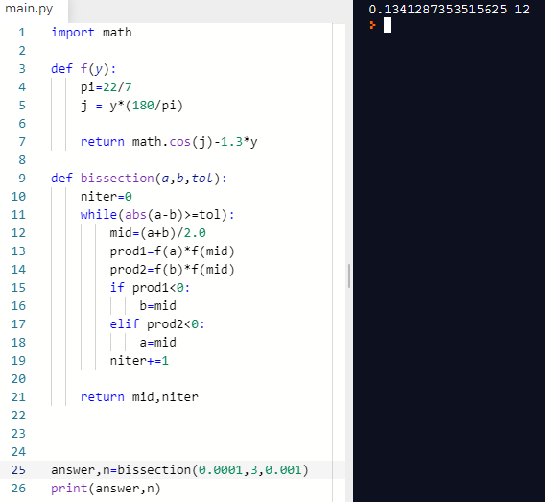

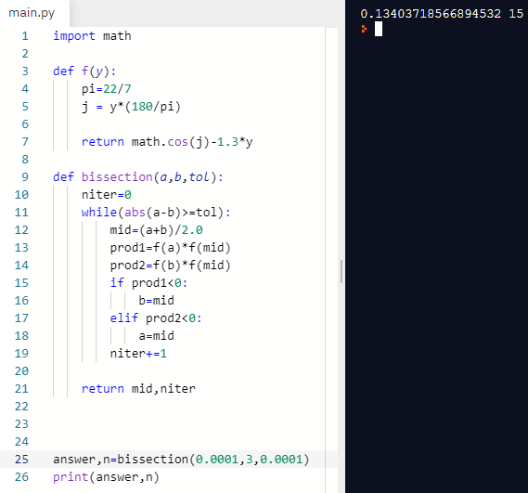

2)

import math

def f(y):

pi=22/7

j = y*(180/pi)

return y*math.cos(j)-2*y**2+3*y-1

def bissection(a,b,tol):

niter=0

while(abs(a-b)>=tol):

mid=(a+b)/2.0

prod1=f(a)*f(mid)

prod2=f(b)*f(mid)

if prod1<0:

b=mid

elif prod2<0:

a=mid

niter+=1

return mid,niter

answer,n=bissection(1,3,0.0001)

print(answer,n)

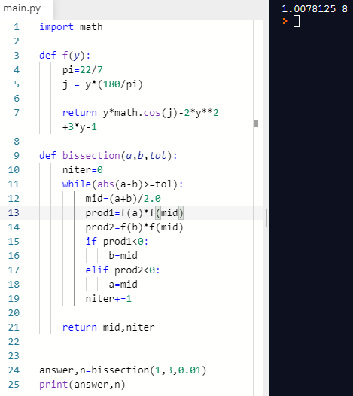

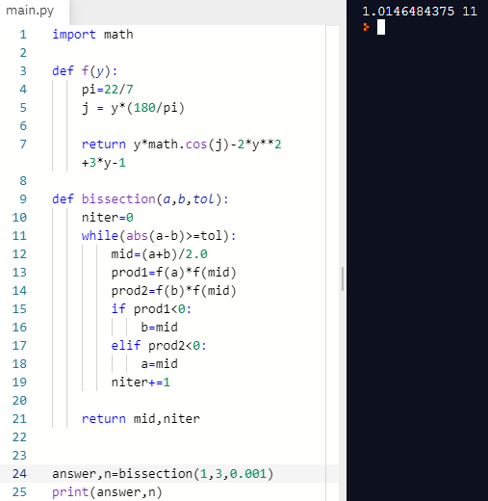

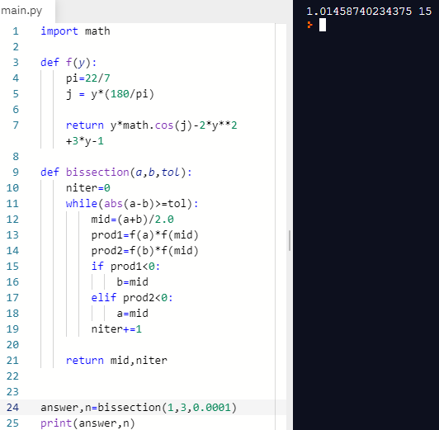

3)

import math

def f(y):

pi=22/7

j = y*(180/pi)

return 2*y*math.cos(2*j)-(y+1)*2

def bissection(a,b,tol):

niter=0

while(abs(a-b)>=tol):

mid=(a+b)/2.0

prod1=f(a)*f(mid)

prod2=f(b)*f(mid)

if prod1<0:

b=mid

elif prod2<0:

a=mid

niter+=1

return mid,niter

answer,n=bissection(-3,4,0.0001)

print(answer,n)

